EXP-:1

**Practice basic bash, IO redirection, pipe, file and directory operations, searching files, process management and vi/nano editor commands.**

NO1

$whoami To display the system's username

$whoami [OPTION]

$whoami –help It gives the help message and exit.

$whoami –version It gives the version information and exit.

NO2

$who [options] [filename]

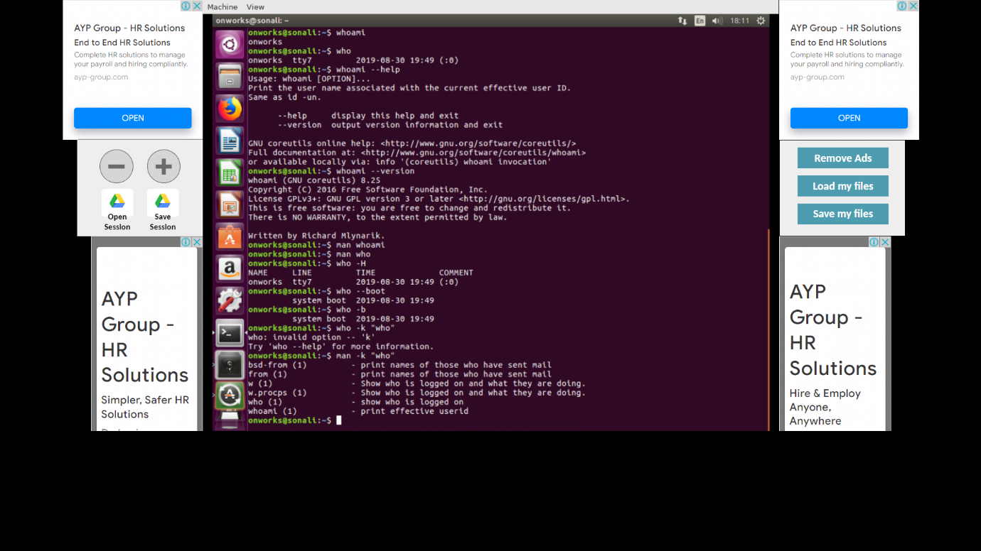

NO3

pwd stands for Print Working Directory. It prints the path of the working directory, starting from the root.  
pwd is shell built-in command(pwd) or an actual binary(/bin/pwd).  
$PWD is an [environment variable](https://www.geeksforgeeks.org/environment-variables-in-linux-unix/) which stores the path of the current directory

|  |  |
| --- | --- |
| -L,--logical | If the [environment variable](https://www.computerhope.com/jargon/e/envivari.htm) PWD contains an [absolute name](https://www.computerhope.com/jargon/a/absopath.htm) of the current directory with no "." or ".." components, then output those contents, even if they contain [symbolic links](https://www.computerhope.com/jargon/s/symblink.htm). Otherwise, fall back to default (-P) behavior. |
| -P, --physical | Print a fully resolved name for the current directory, where all components of the name are actual directory names, and not symbolic links. |
| --help | Display a help message, and exit. |
| --version | Display version information, and exit. |

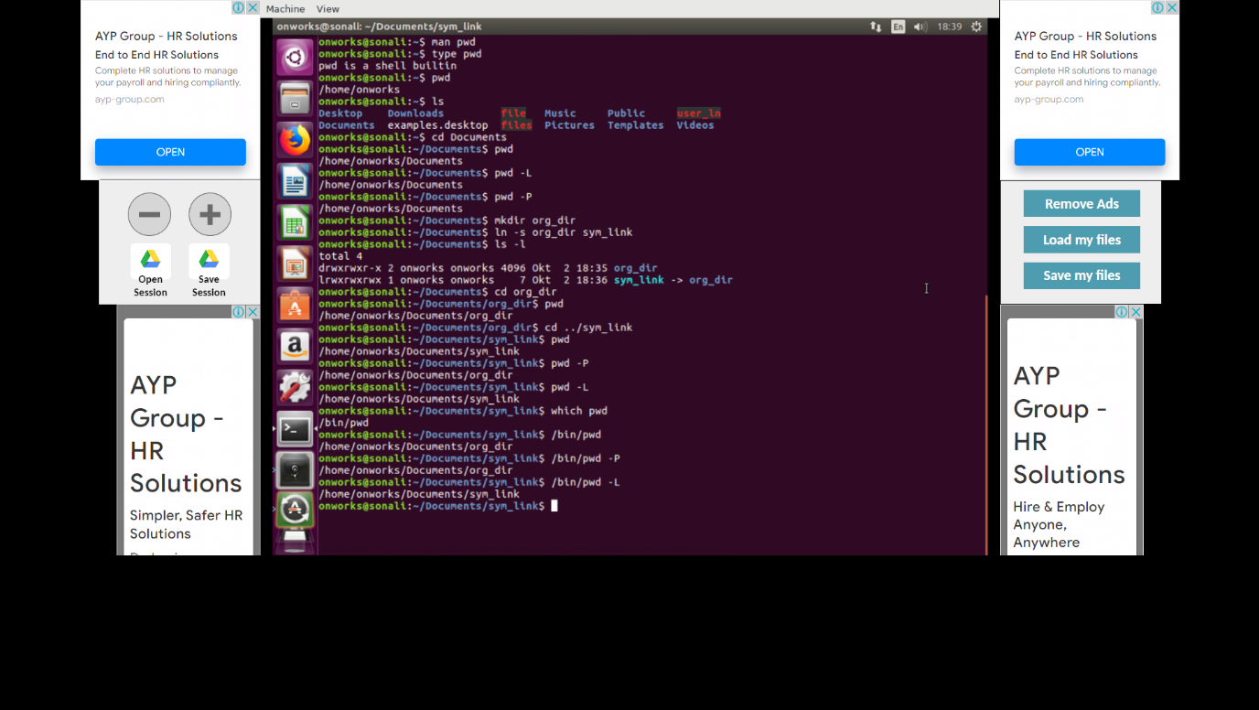

NO4

ls is a Linux shell command that lists directory contents of files and directories

$ ls

'file name.txt' filename.txt

$ ls /home/linuxconfig

$ ls -l To show long listing information about the file/directory.

$ls -1  Display One File Per Line

$ ls -ltr  Order Files Based on Last Modified Time (In Reverse Order)

$ ls -I  Display File Inode Number

$ ls -A To show the hidden files, but not the ‘.’ (current directory) and ‘..’ (parent directory).

$ ls -lh  (h stands for human readable form) : To display file size in easy to read format. i.e i.e M for MB, K for KB, G for GB

$ ls -lt  Order Files Based on Last Modified Time

$ ls -R  Display Files Recursively

$ ls -a Display Hidden Files Using ls -a

$ls -t Open Last Edited File

$ ls -i  Hide Control Characters

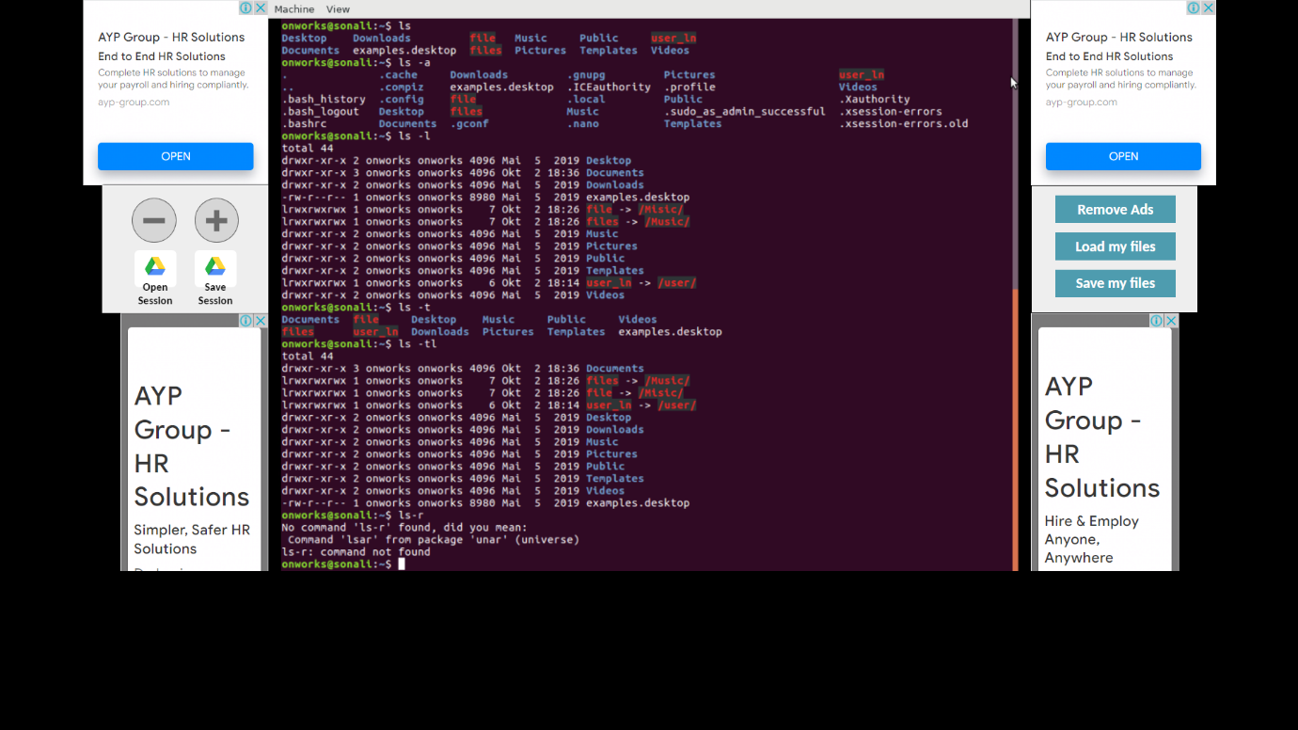

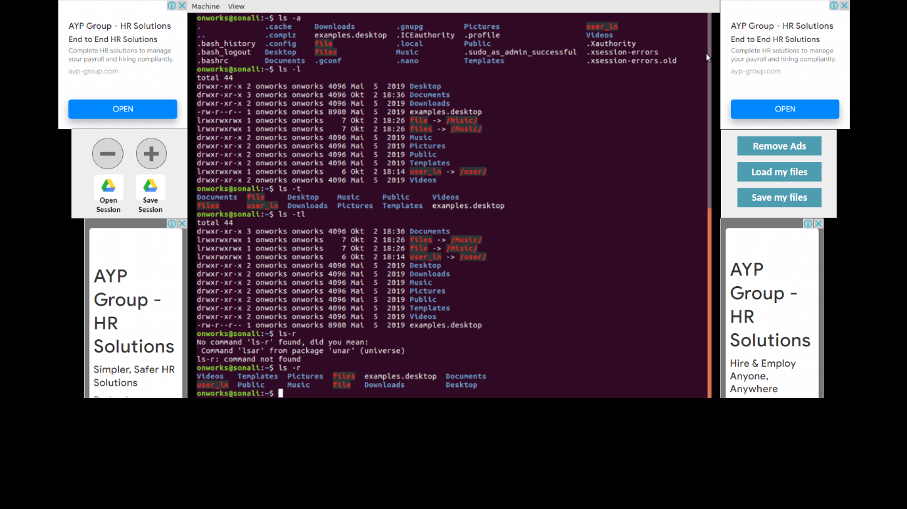

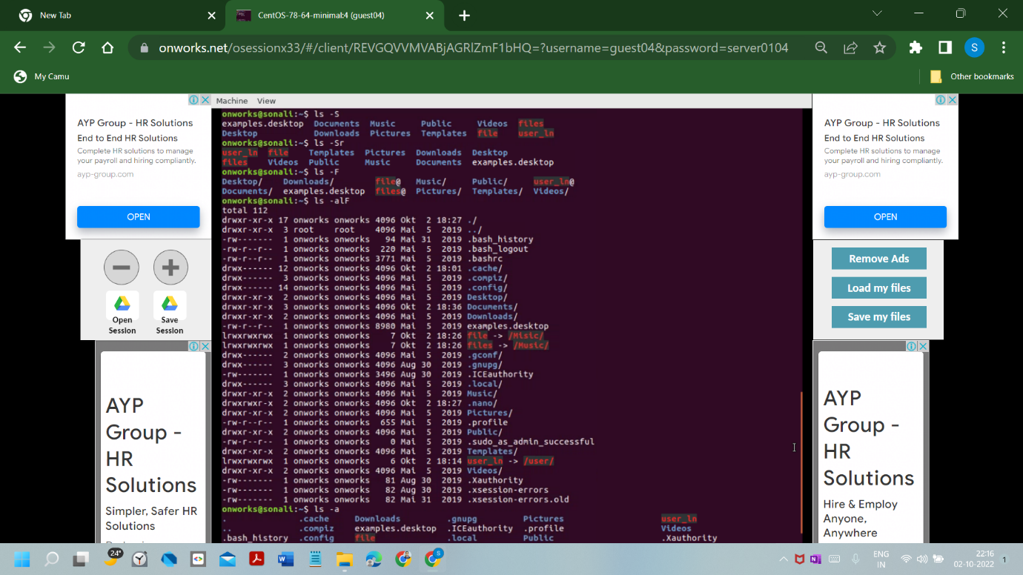

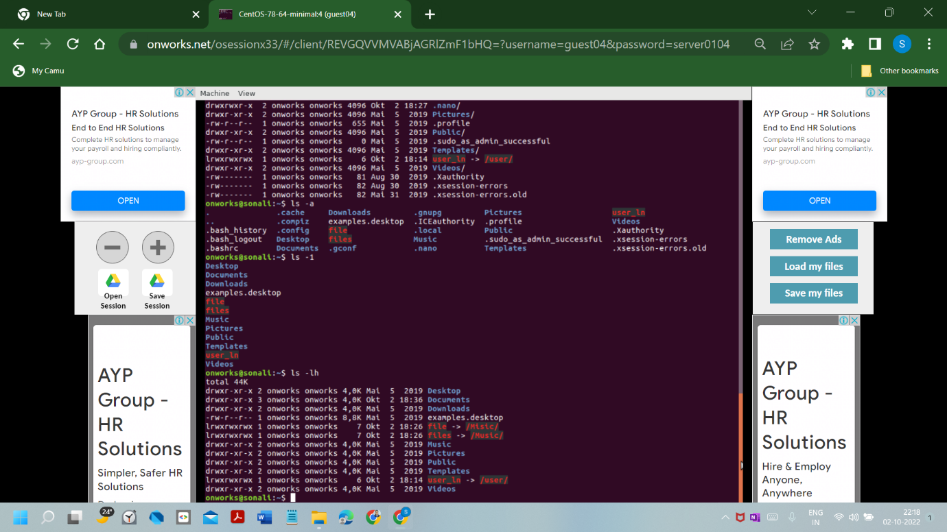

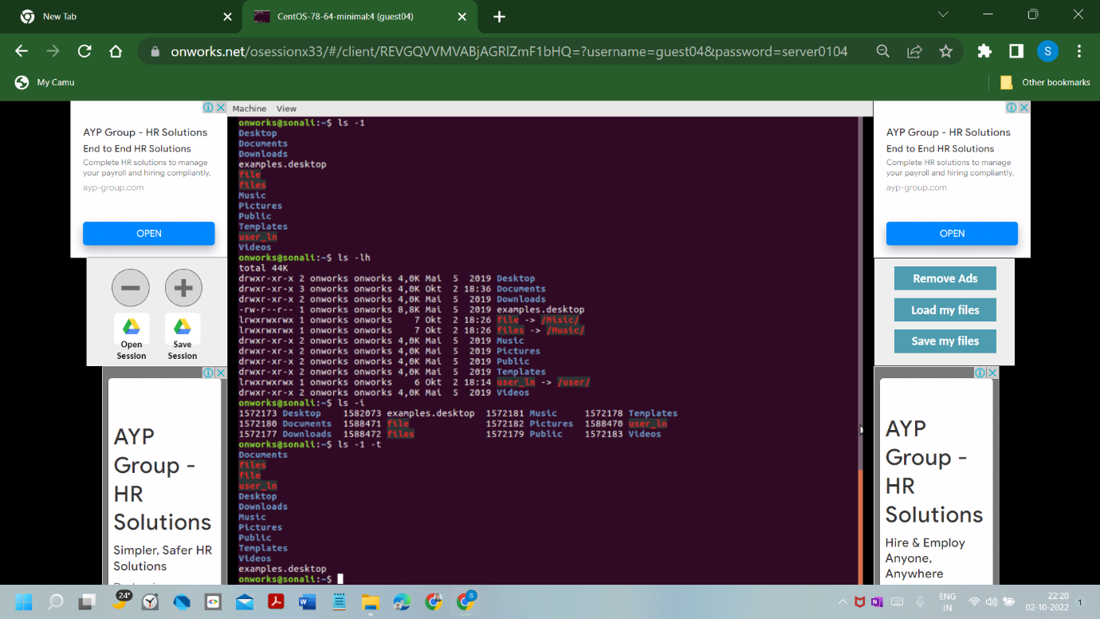

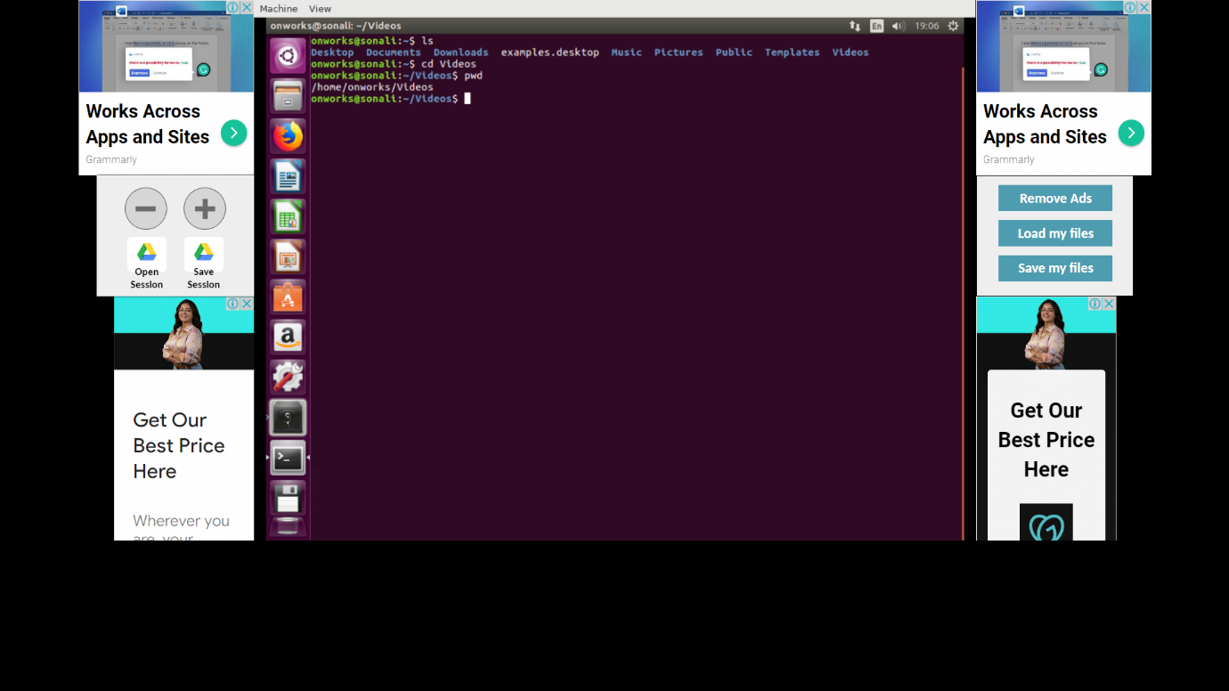

NO5

cd is a shell builtin, and its behavior may slightly differ from shell to shell.

cd <dirname>

cd < current directory> <specified directory>

cd ~  Navigate to the Home Directory

cd -  Navigate to the Previous Directory

cd  ../  To switch to the /usr/local directory (one level up from the current directory

cd ~username  navigate to another user’s home

$cd Dir1/Dir2/Dir3....  To move two levels up to the /usr directory (the parent’s parent),

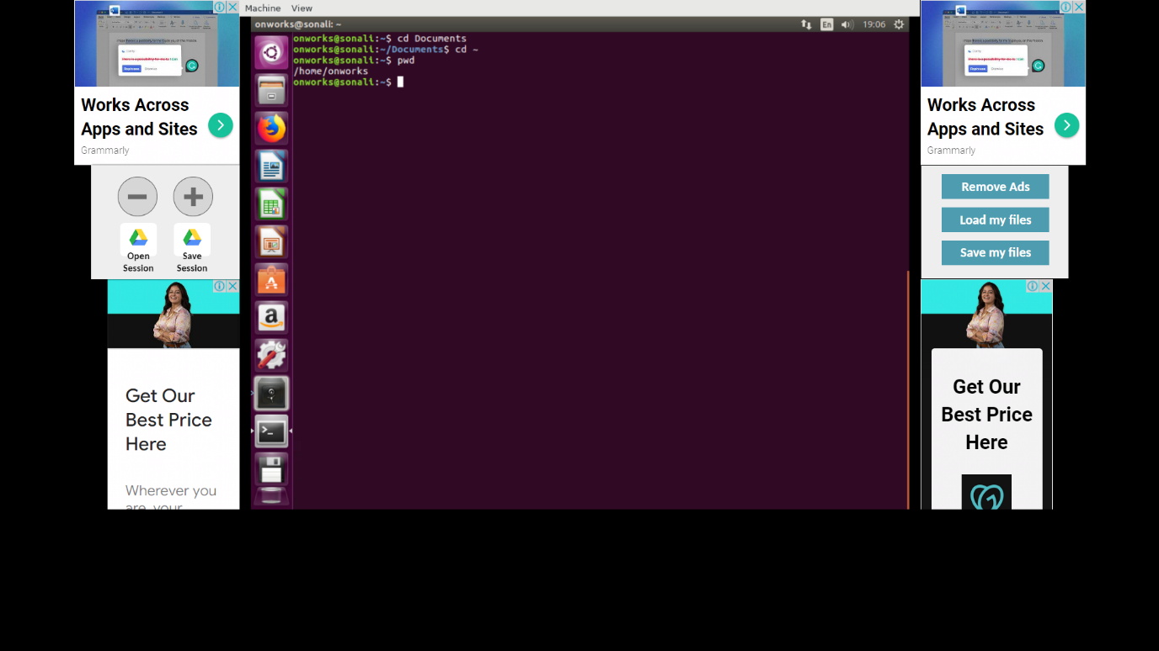

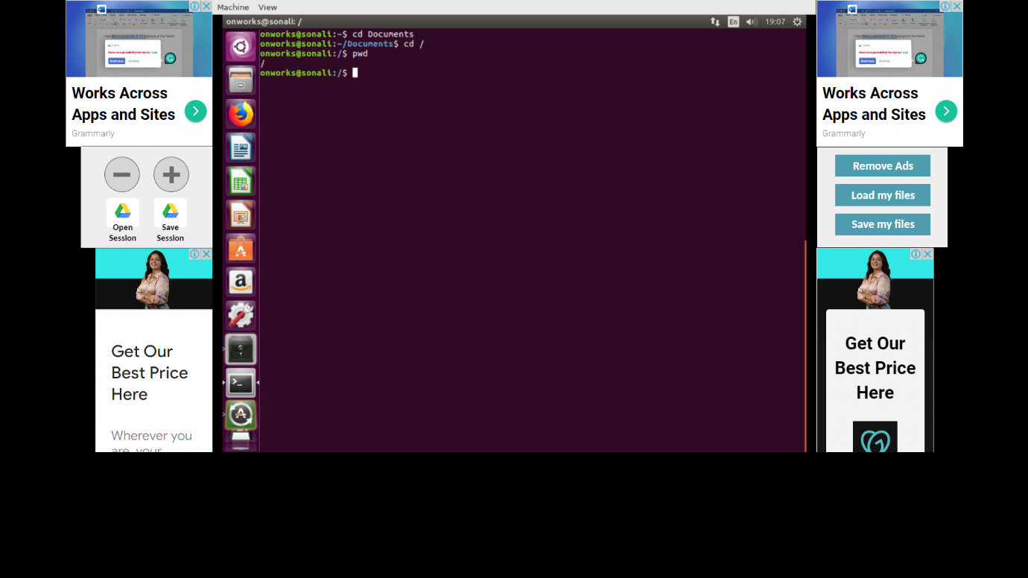

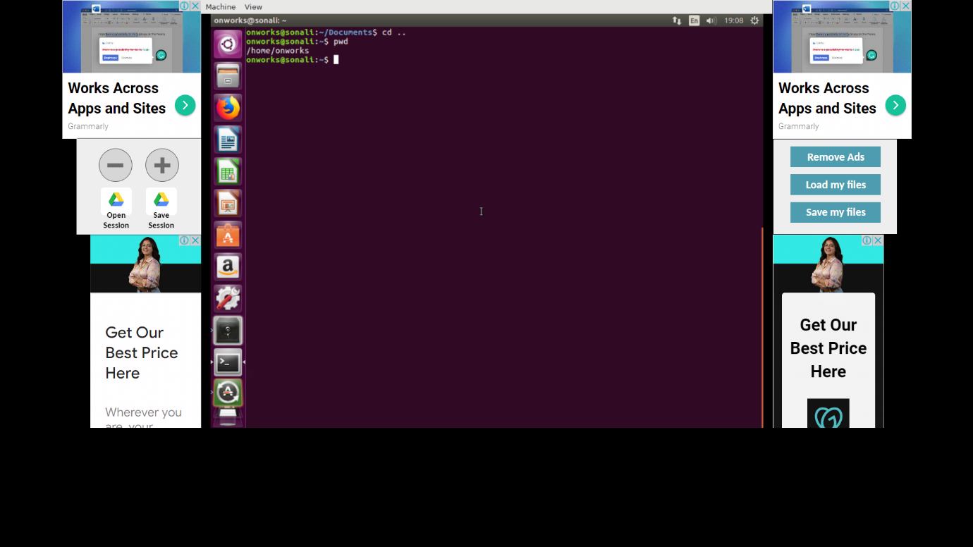

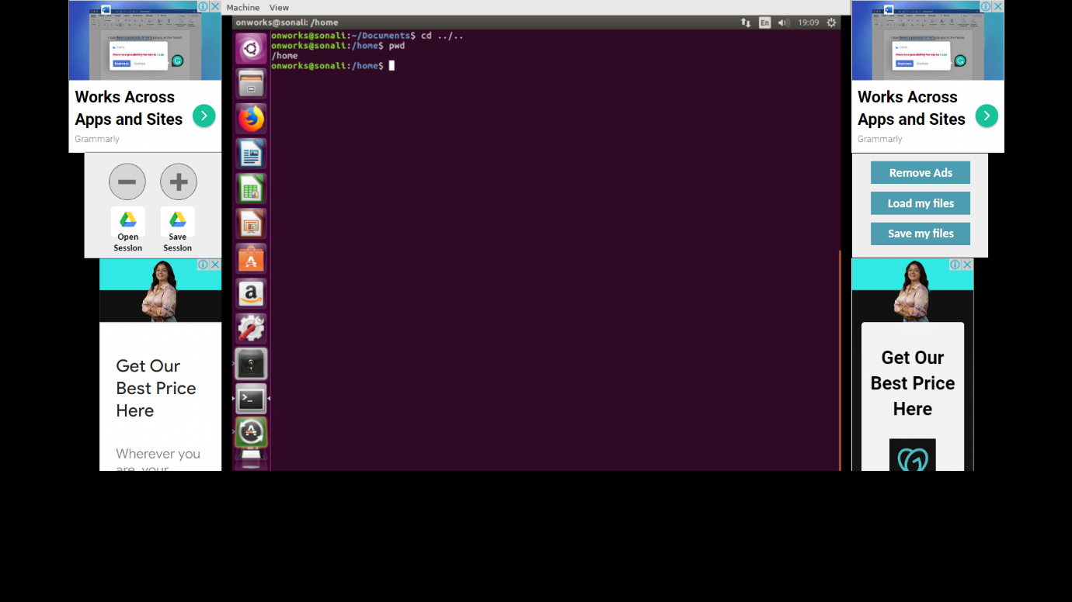

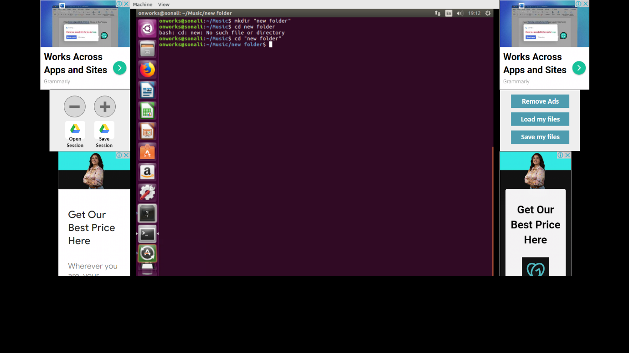

NO6

The most common way to start a vi session is to tell it which file to edit. To edit a file named filename, use the command:

$vi filename

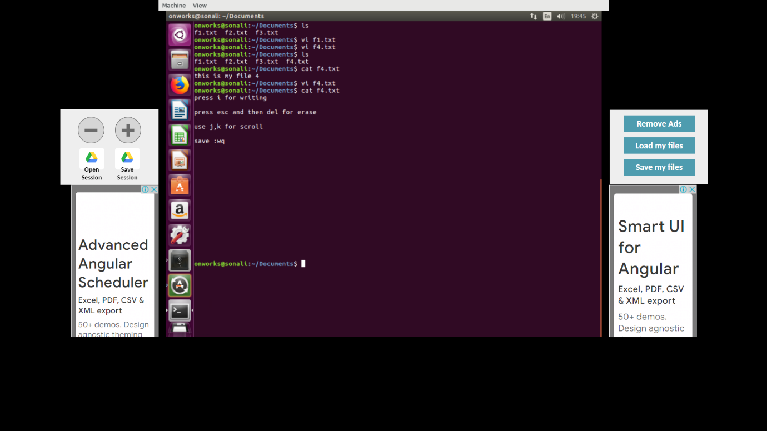

NO7

$nano filename Opening and Creating File

$nano –version check if it is installed on your system type

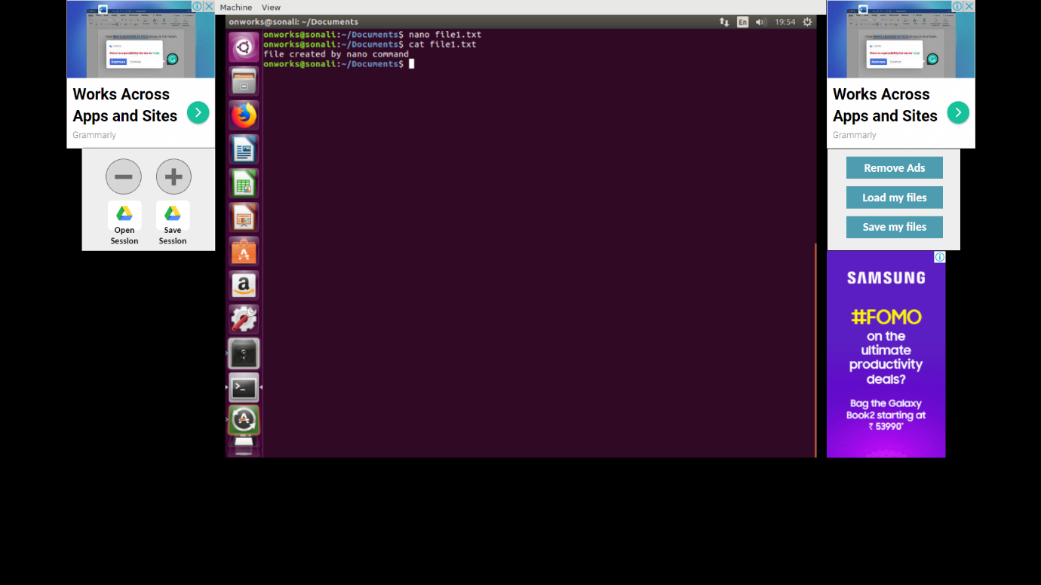

NO8

The echo command in Linux is used to display a string provided by the user.

$echo [option] [string]

$echo -e 'Hello, \vWorld, \vthis \vis \vPNAP!'Use \v to create vertical tab spaces

$echo -e 'Hello, \tWorld!' Add horizontal tab spaces by using \t

$sudo echo -e 'Hello, World! \nThis is PNAP!' >> test.txtUse > or >> to include the string in an echo command in a file

$echo -e 'Hello, World! \c This is PNAP!'  option allows you to use escape characters

$/bin/echo –help ;Use the --help argument to list all available echo command options:

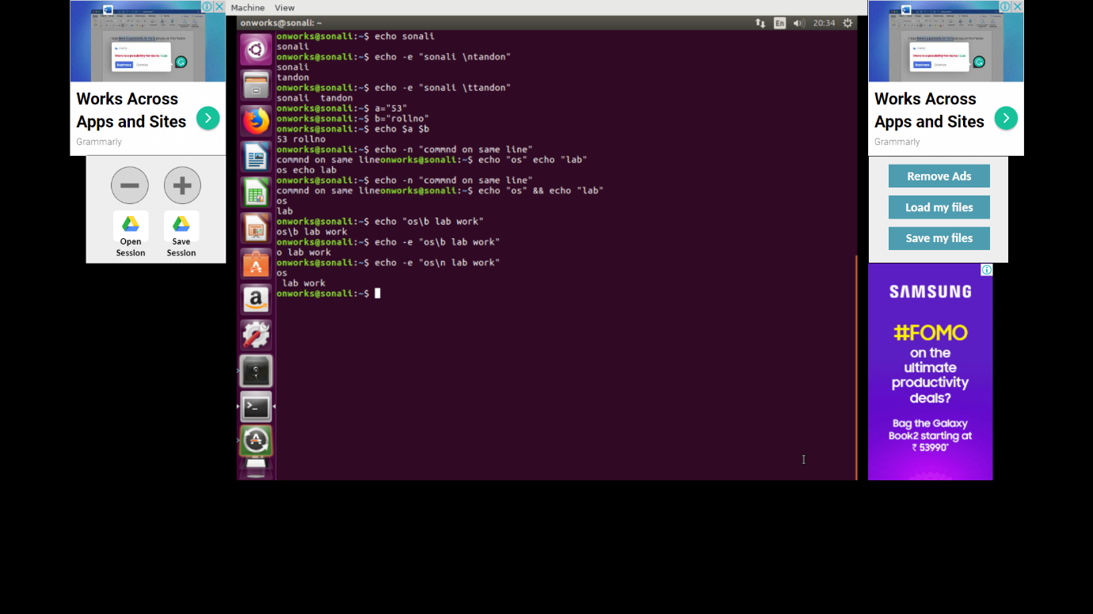

NO9

$ sudo hostnamectl set-hostname newNameHere To change the currently set hostname, type the following hostnamectl command

$ hostnamectl Once the name is updated, you can verify the updates using

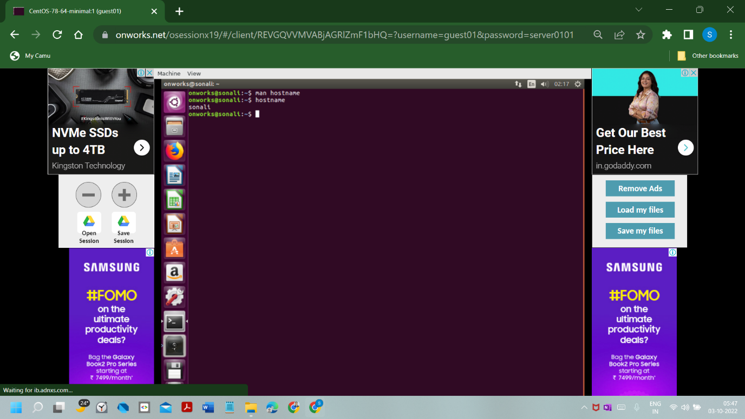

NO10

$touch FILE Creating a single file

$touch FILE1 FILE2 FILE3 The syntax to create multiple files

$touch -a FILE change the Access time

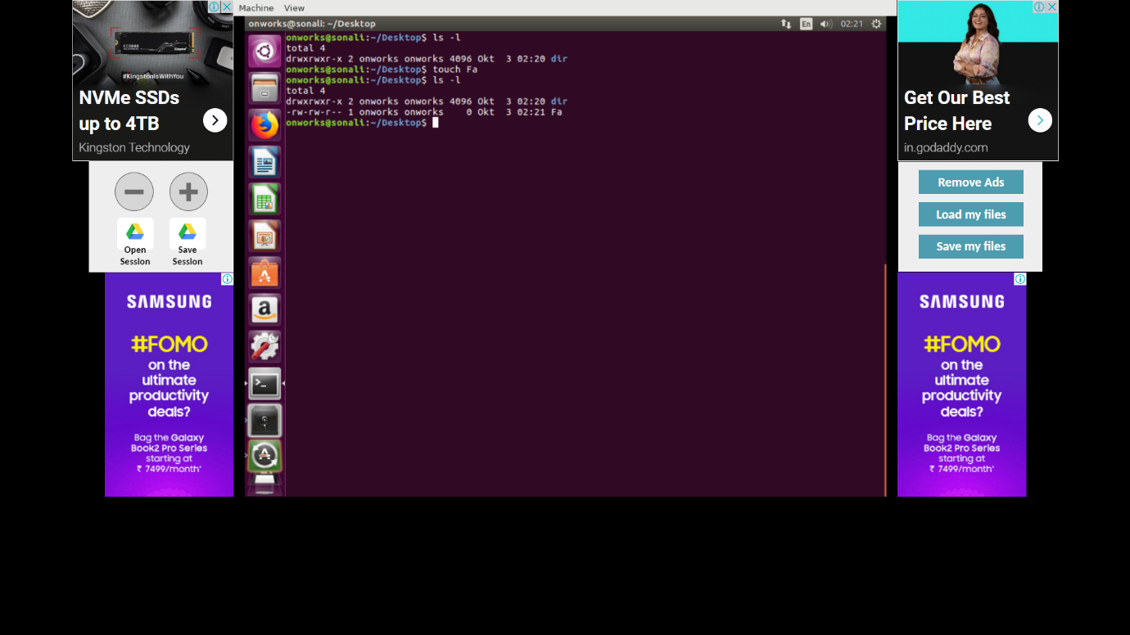

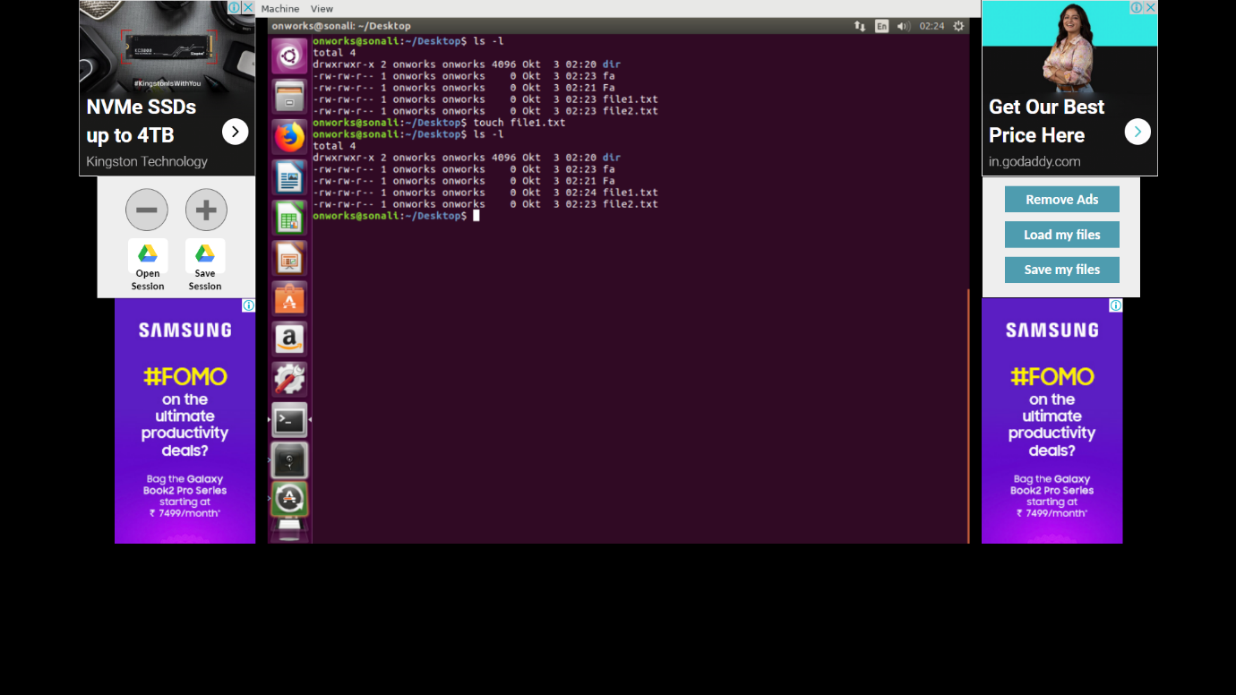

NO11

$man [opt] The command-line prograym man is used for displaying Unix and Linux manual pages (usually called manpages).

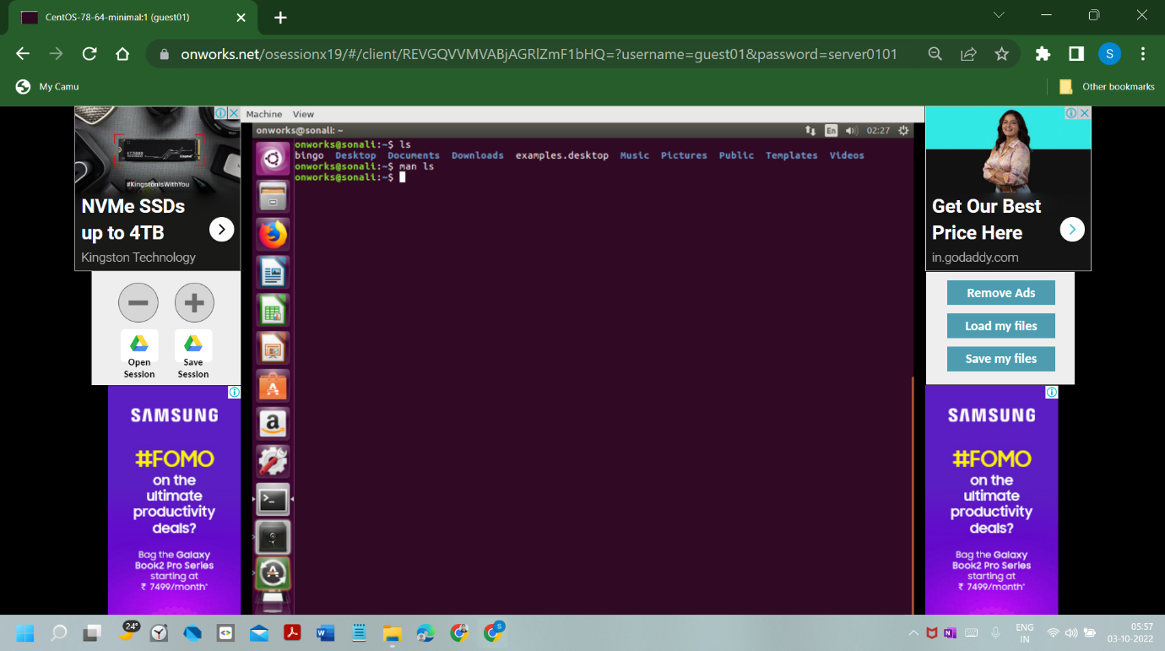

NO12

$mkdir [option] dir_name

$mkdir linux

$mkdir ls -R show recursive directory tree

$ mkdir book_titles Create a simple directory at current folder/directory

$ mkdir -p [directories]  This option enables the user to create parent directories as per the requirement.

$ mkdir -v [directories] This option displays a verbose information of each directory that is created

$ mkdir –version  This option will print the information of the version and exit

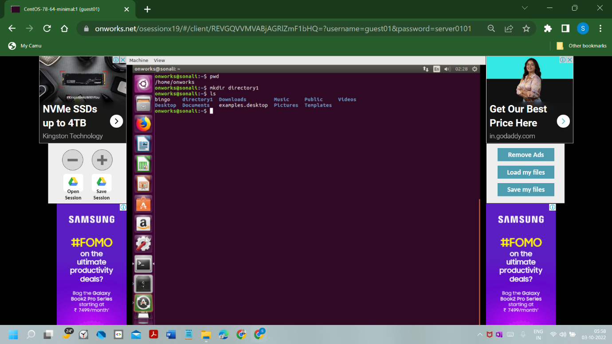

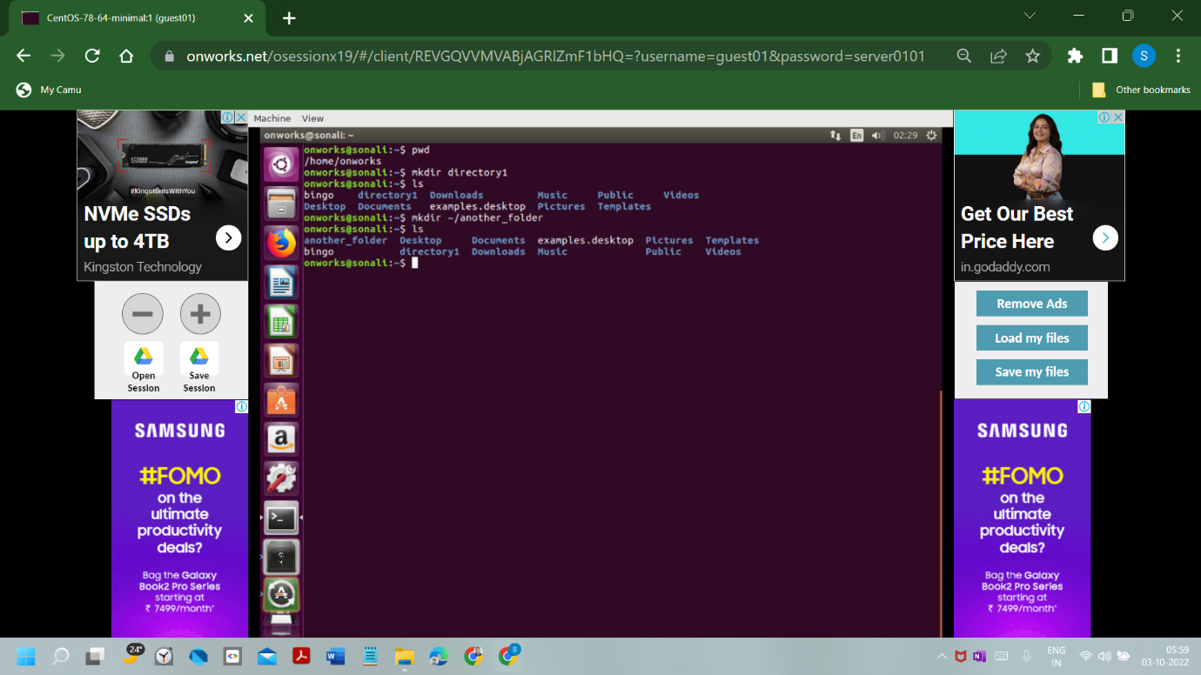

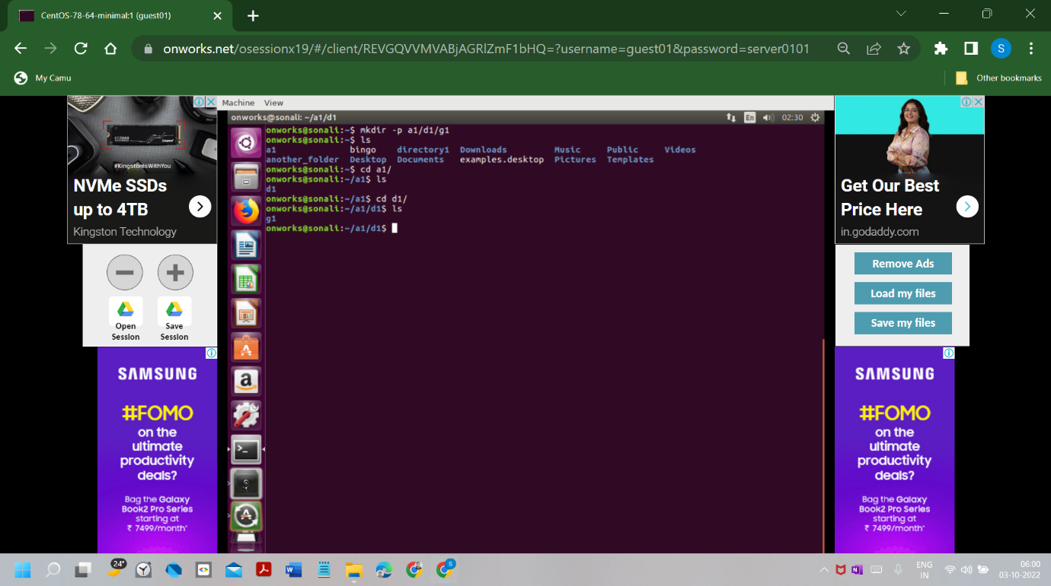

NO13

$Cat [option] [file] general syntax of cat

$cat filename view a single file

$cat file1 file2 To view multiple files

$cat -n filename view contents of a file preceding with line numbers

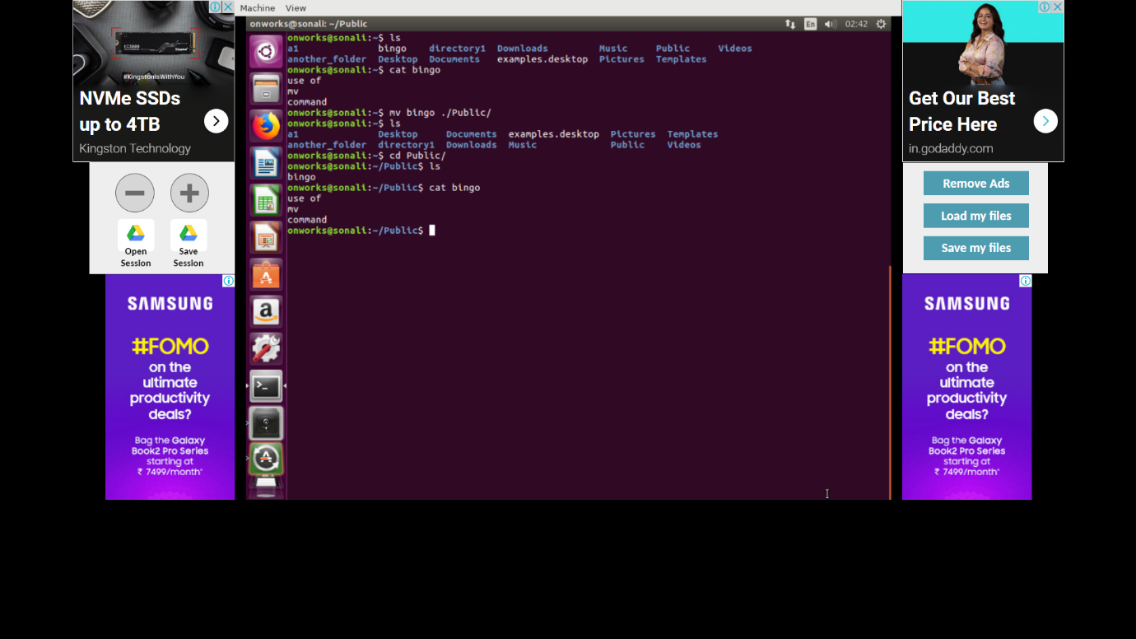

NO14

$mv [option] source destinction

$mv [options] source_file target_file_location

$mv filename other_directory Move files from one location to another

$mv file1 file2 file3 destination_directory Move multiple files simultaneously

$mv dir another_directory Move a directory from one place to another

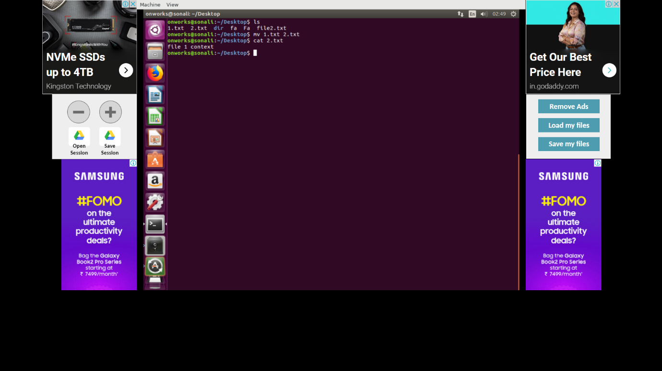

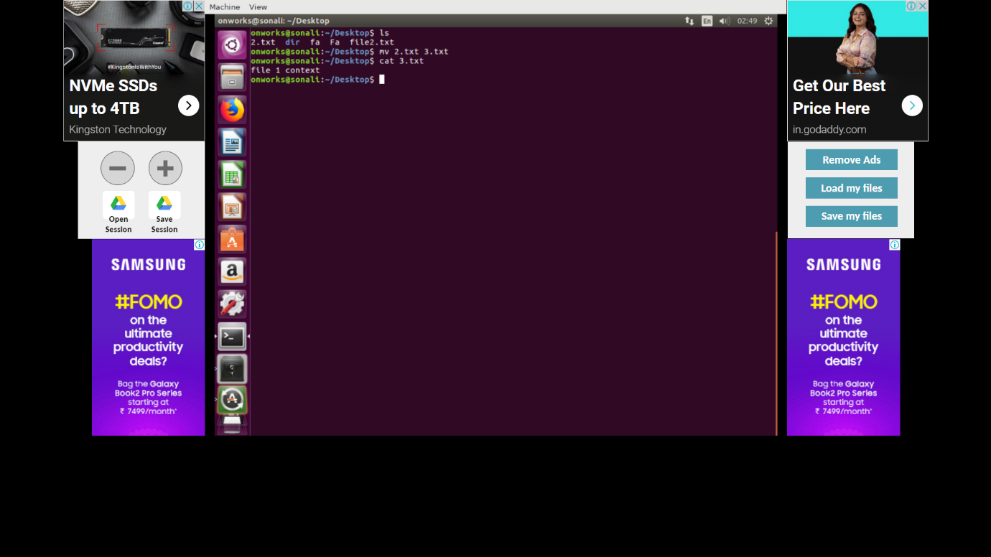

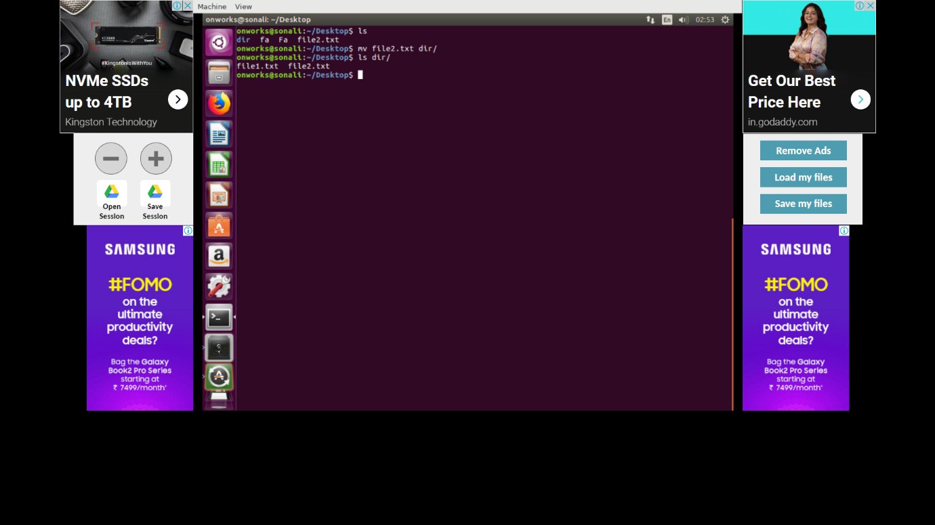

NO 15

Cp [..file/dir-src][dest]

$cp -R Src_directory Dest_directory Two directory names

$cp {options} source_file target_file copy a file to another file

$cp {options} source_file   target_directory  Copy File(s) to another directory or folder

$cp {options} source_directory target_directory copy directory to directory

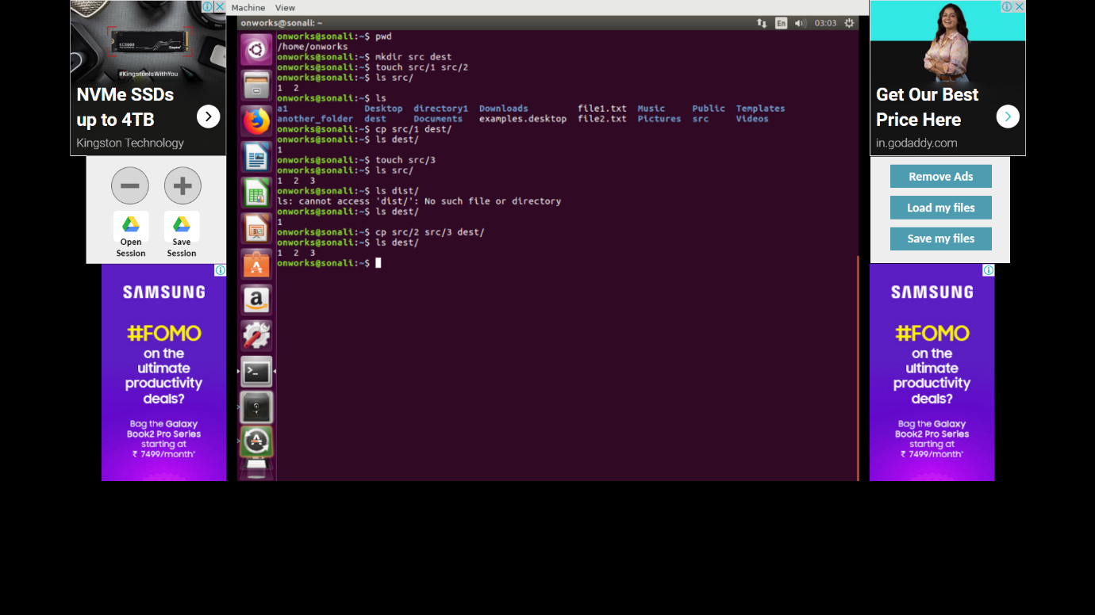

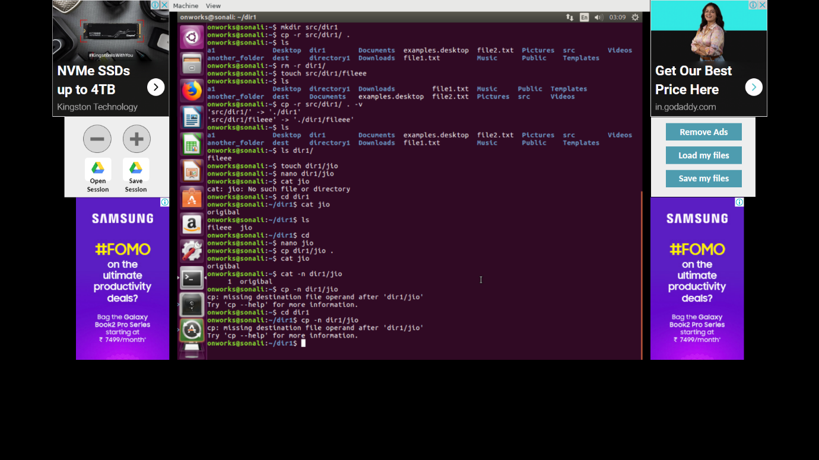

NO 16

$cat [opt] [file].. display contents of file

$cat test test1 view multiple files

$cat >test2 create a file with cat

$cat song.txt | more

$cat song.txt | less

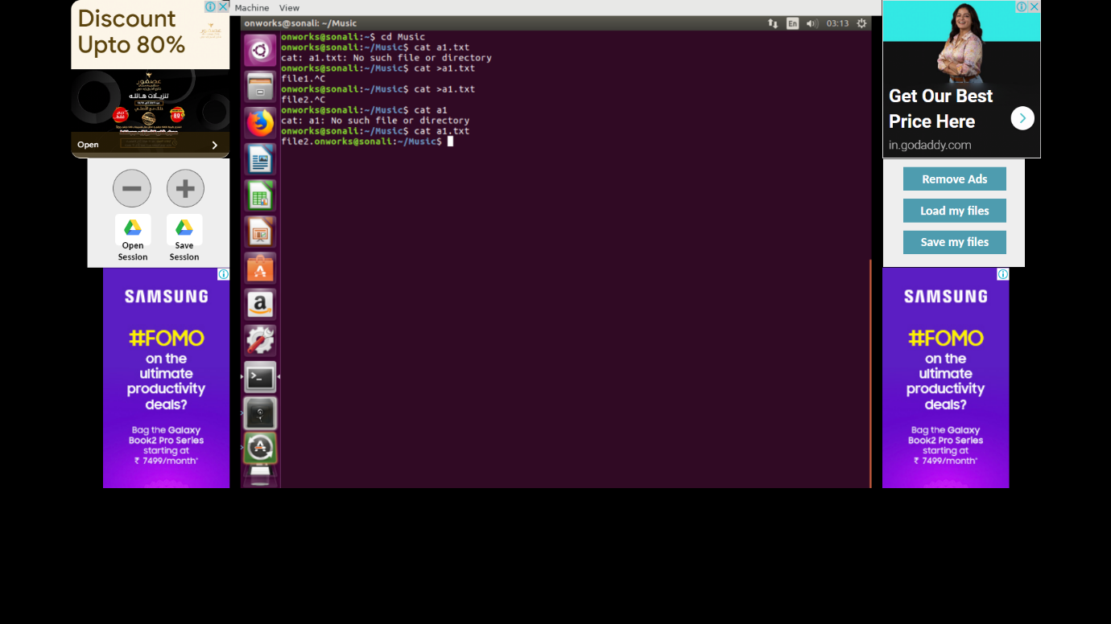

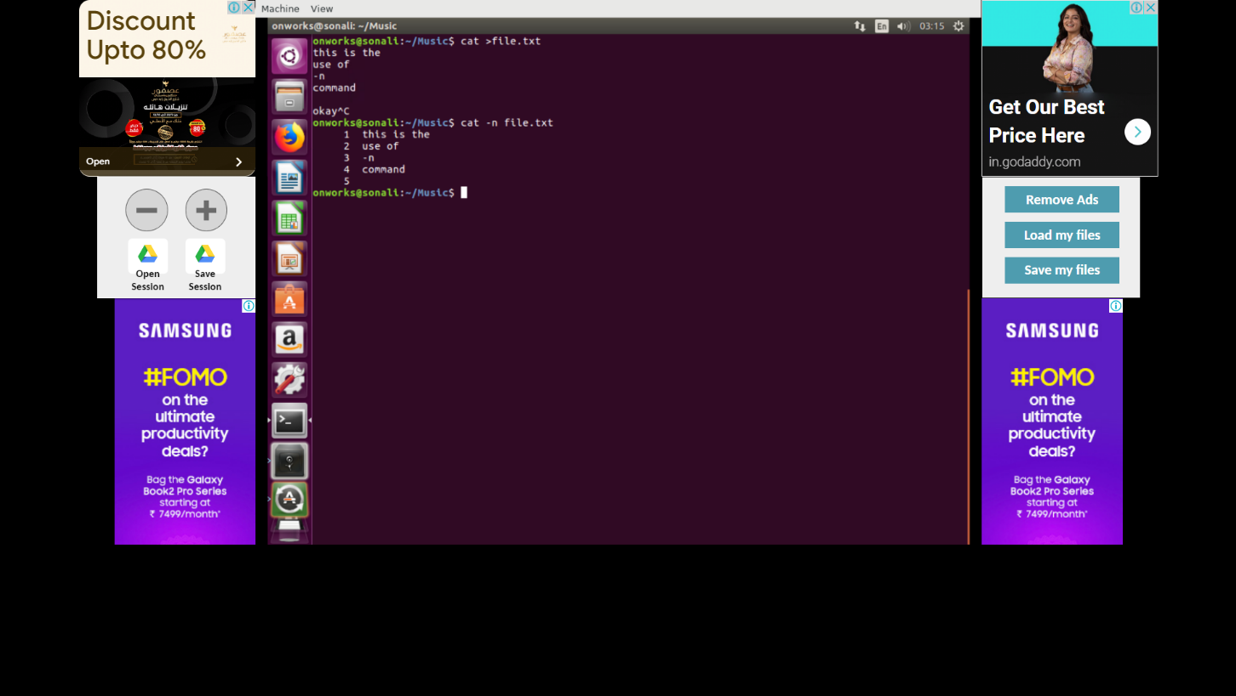

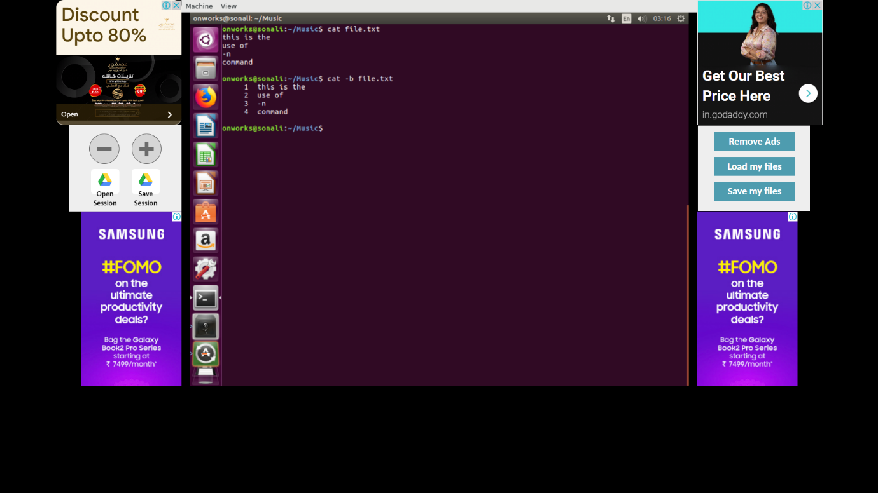

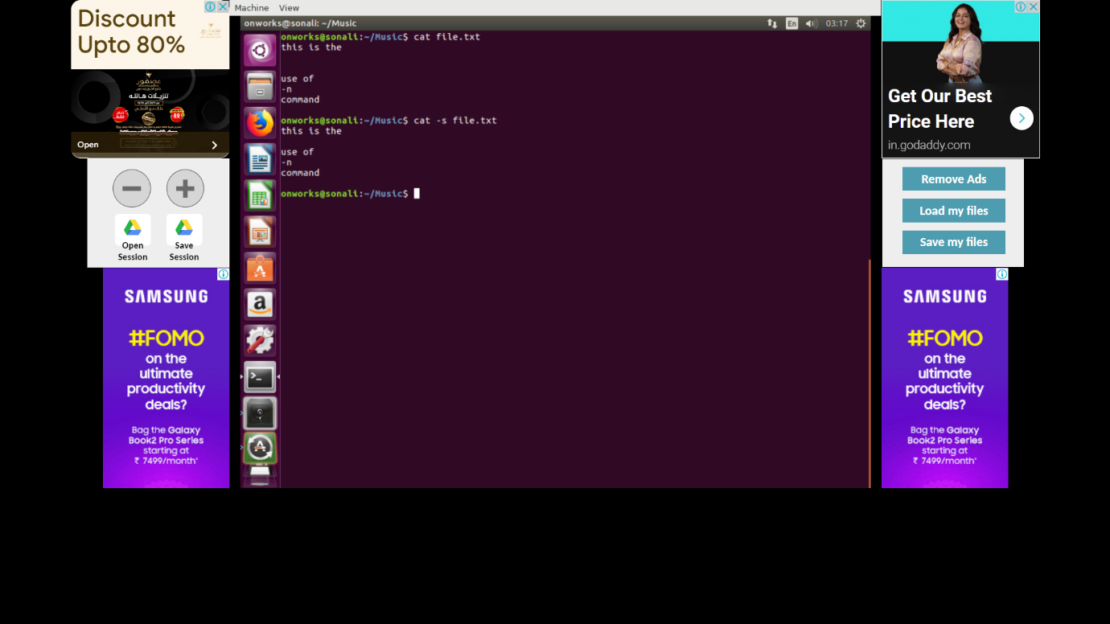

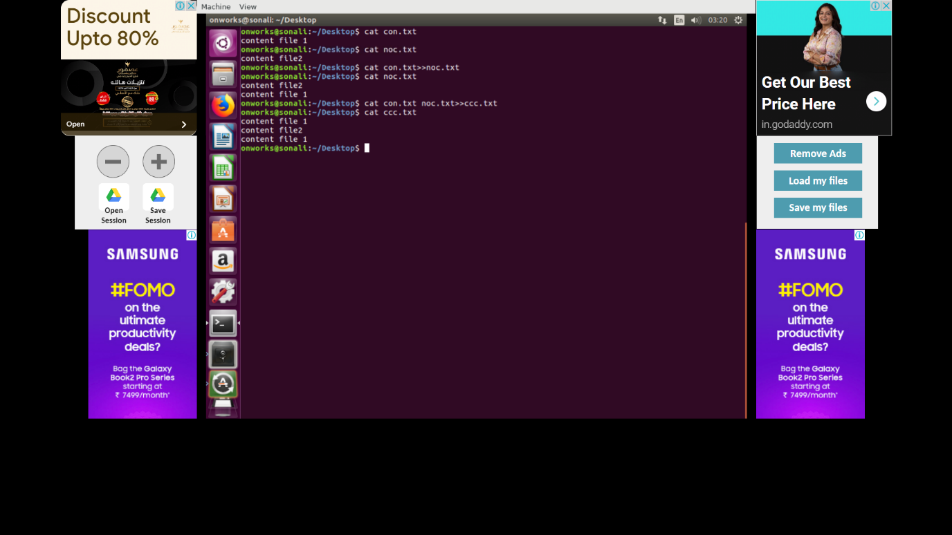

NO17

$rm [OPTION]... FILE...

rm command is used to remove objects such as files, directories, symbolic links and so on from the file system like UNIX

$ rm b.txt c.txt Removing more than one file at a time

$ rm a.txt Removing one file at a time

$ rm -i d.txt remove regular empty file

$ rm e.txt remove write-protected regular empty file

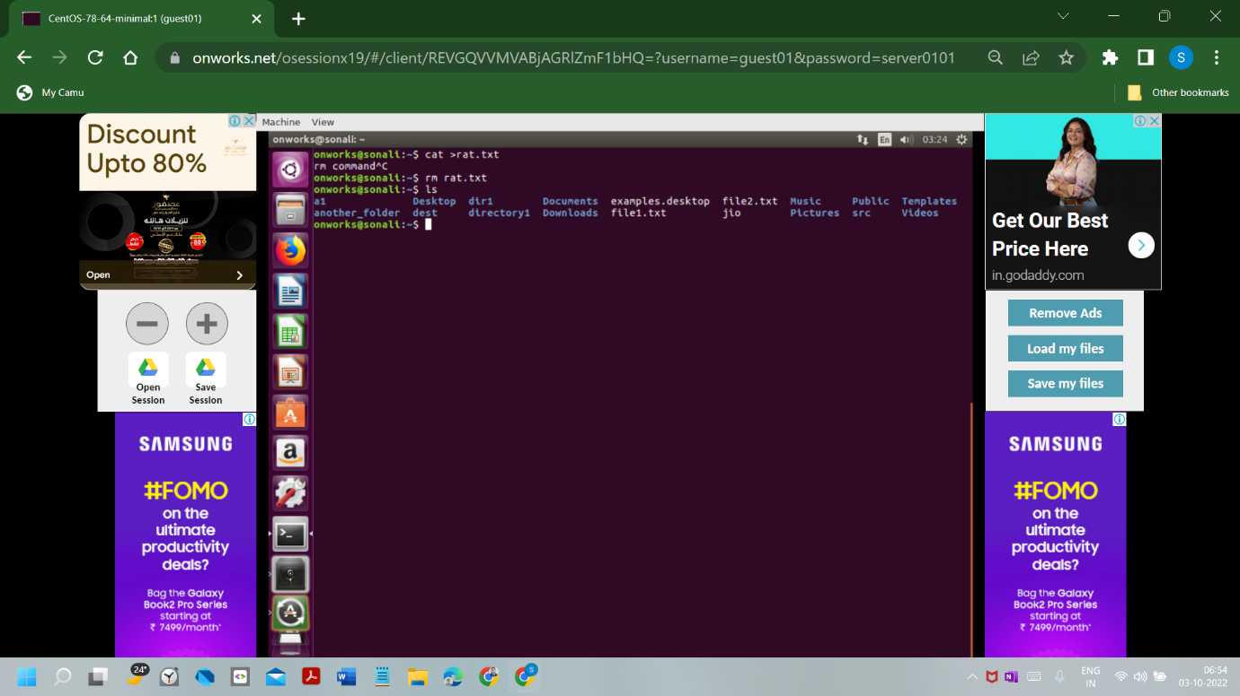

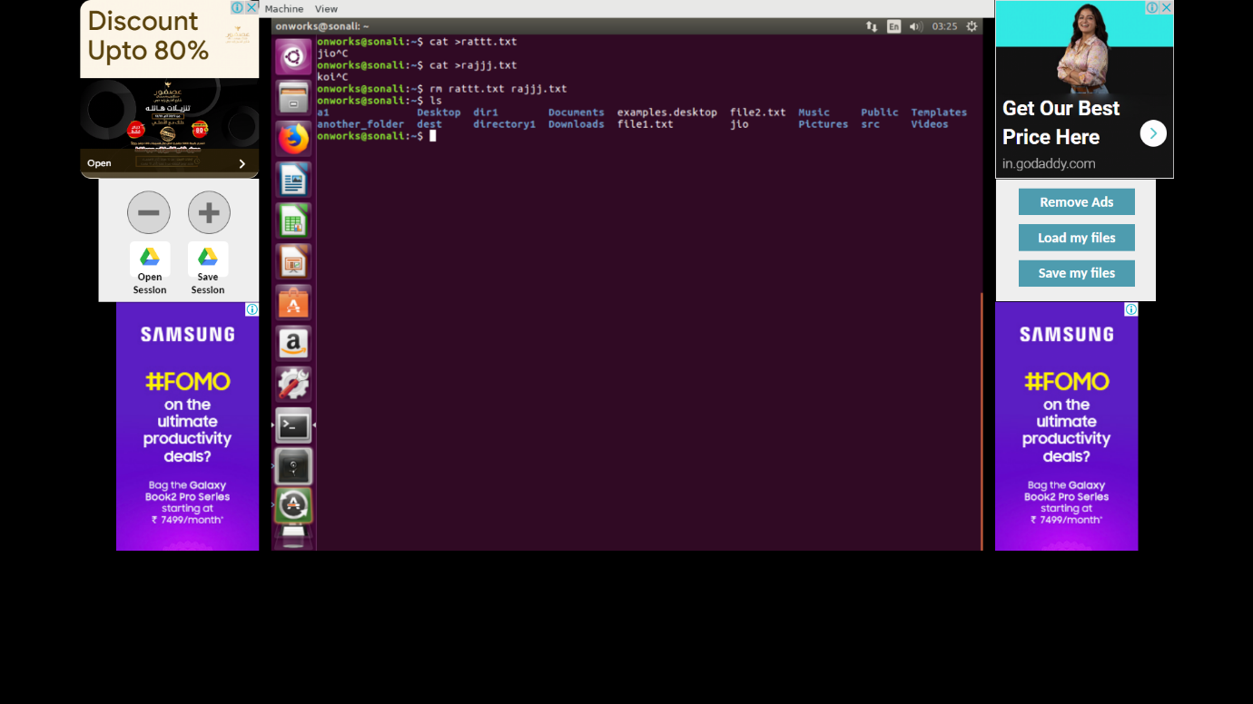

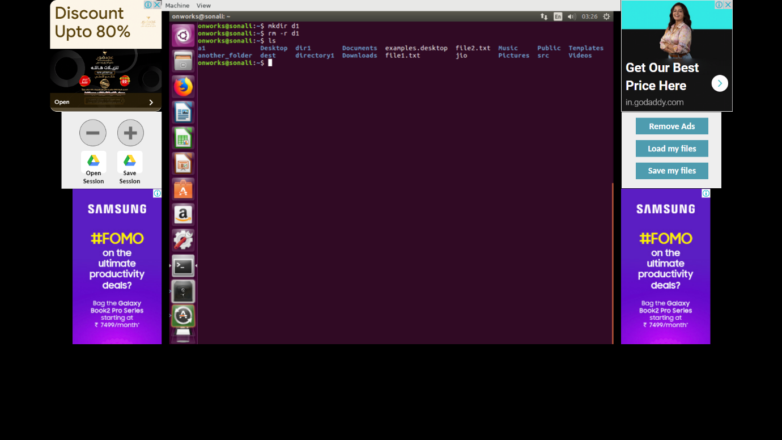

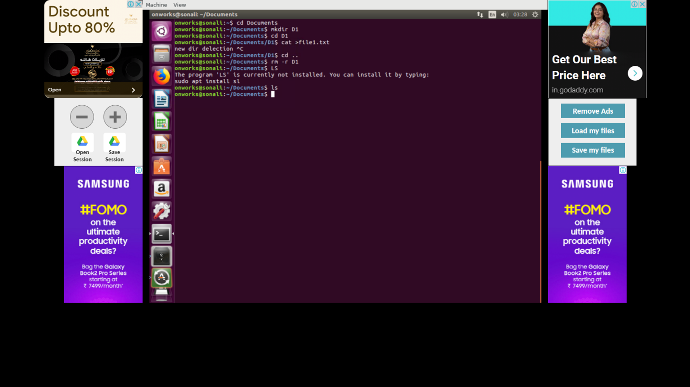

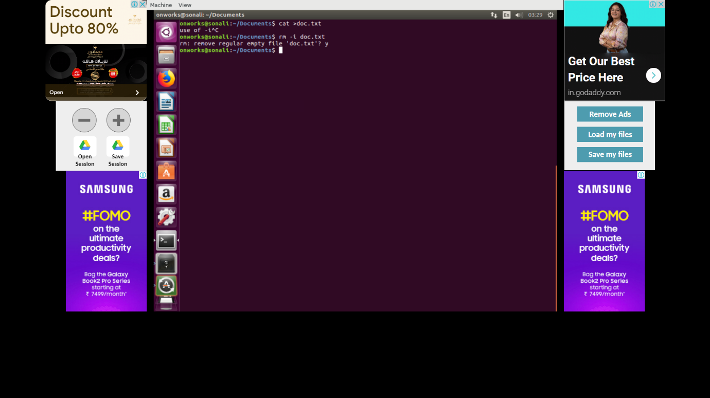

NO 18

$grep [options] pattern [files]

$grep -I ünix”file.txt search for a string case

$grep -w ünix”file.txt checking for whole words in a file

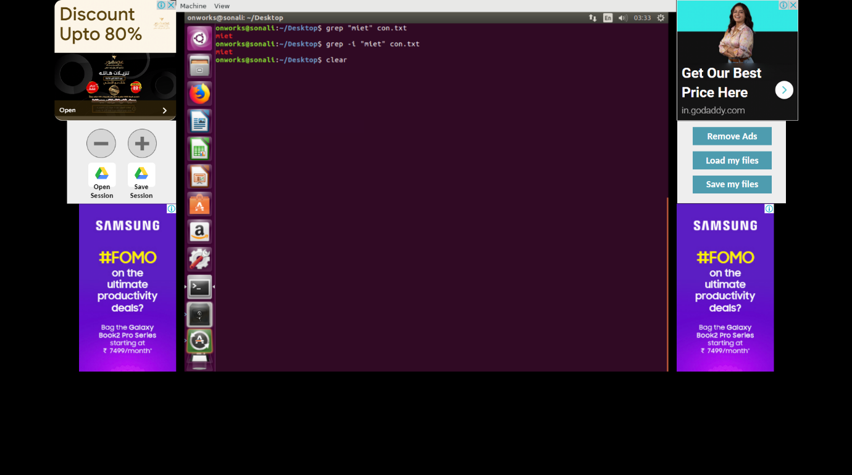

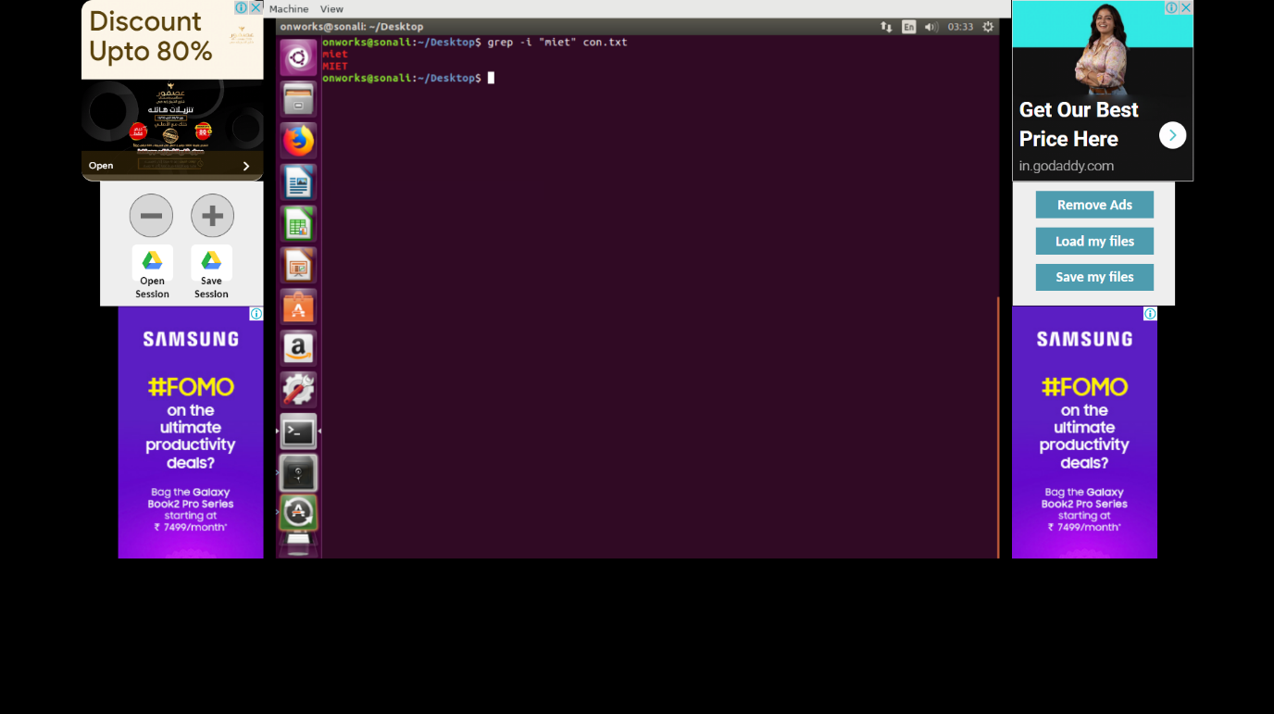

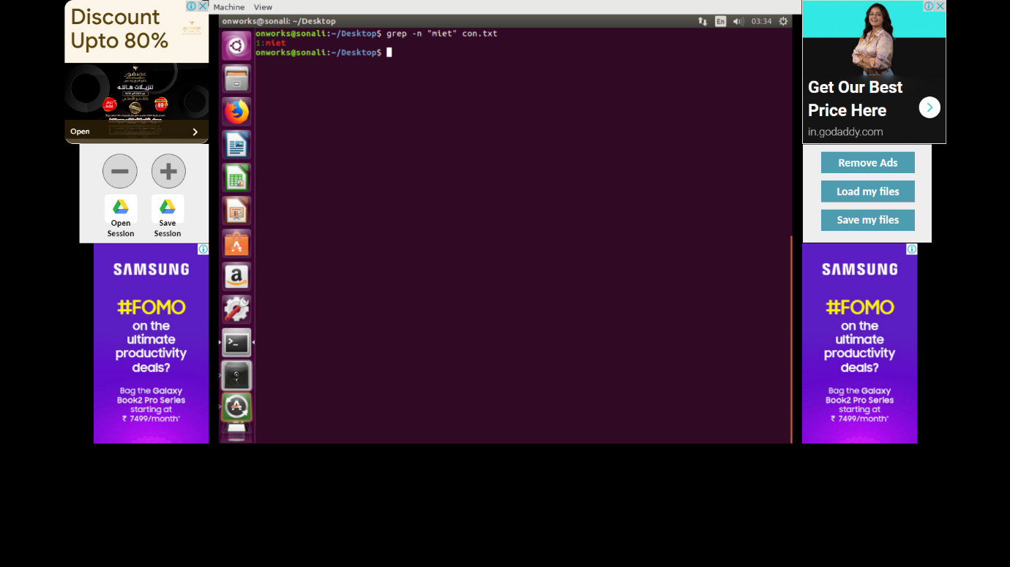

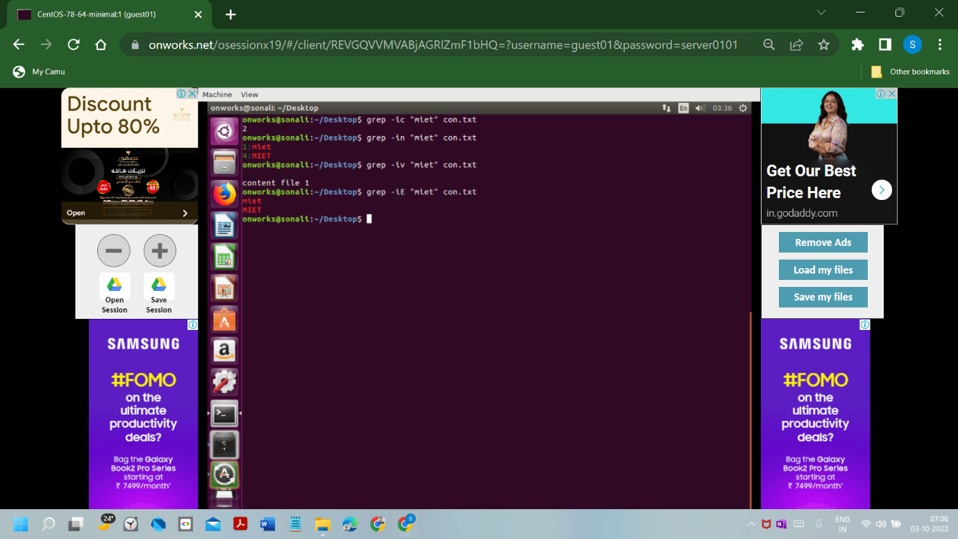

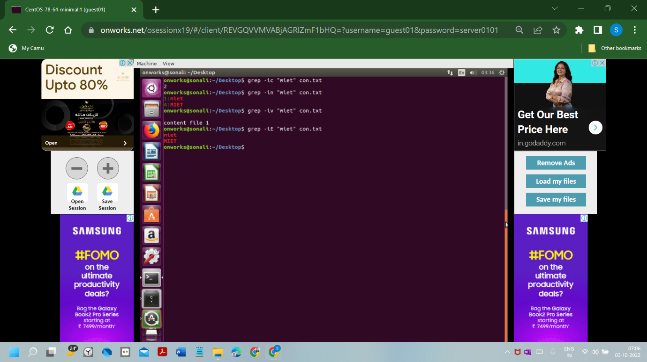

NO19

$date current time and date

$date[option]..[+format]

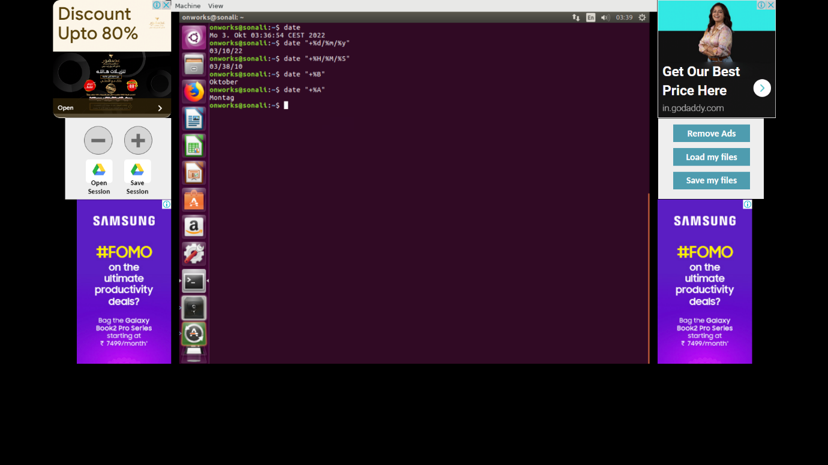

NO 20

$bc to perform any arithmetic operations

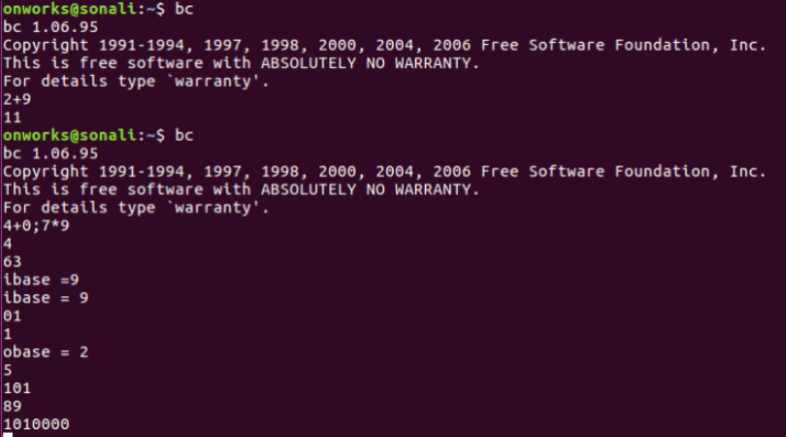

NO 21

$top Display process id

K FOR kill any process.

d For change the delay time interval.

h For help.

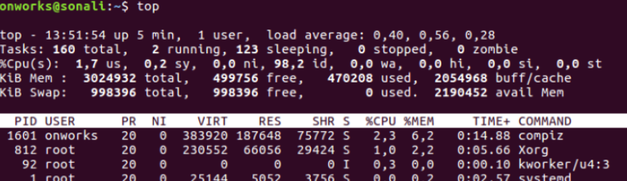

NO 22

$kill -l to display all the available signals

$ps to display a list of running processes.

$kill pid to show how to use pid with Kill Command.

$kill {-signal | -s signal} pid to show how to send signal to processes.

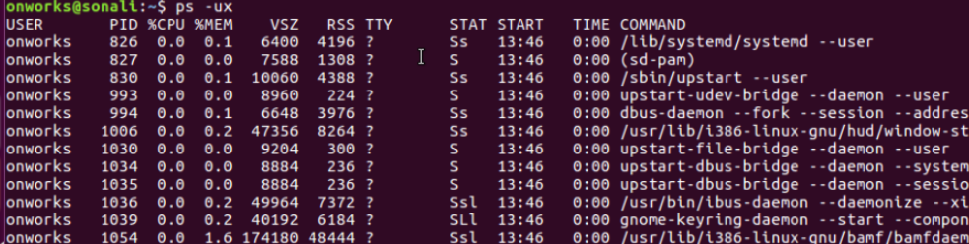 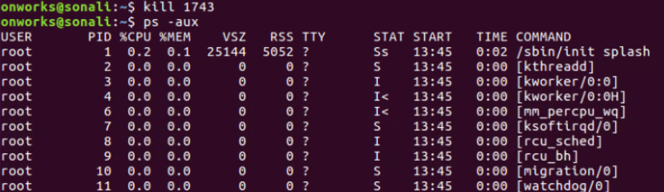

NO 23 and NO 24

$head is used to show the first part of the file.

$head f1.txt f2.txt to show multiple files.

$head -n3 file.txt to show the 3 lines.

$tail is used to show the last part of the file to file

$tail -n3 file.txt to show the 3 lines.



